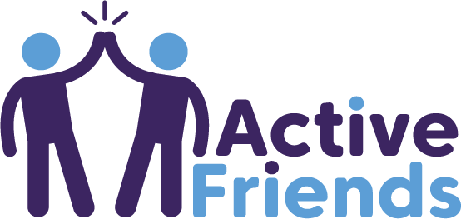

Communications Toolkit

Contents

Active Friends overview
Email to workplaces
Email to community groups
Suggested social media posts
Twitter
LinkedIn: Business facing messaging
Facebook: Community facing messaging

Help us spread the word

Welcome to the Active Friends communications toolkit. This toolkit is designed to help spread the word about Active Friends to local people, organisations, businesses, and community groups. It includes suggested emails for various audiences, as well as social media messages and images, to make it as easy as possible to promote Active Friends. Active Friends is for everyone, so we want to spread the word far and wide!

Active Friends overview

What is Active Friends?
Active Friends is an exciting new online training toolkit from County Durham Sport. It aims to teach individuals how to support and inspire their local communities to move more, improving their health and wellbeing. We know that getting active is easier (and often more enjoyable) with the support of a friend. The free Active Friends toolkit is full of helpful videos, activities, and resources, to provide individuals with the knowledge and skills they need to promote the benefits of physical activity, encourage others to move more, and get moving themselves!

Who can be an Active Friend?
Anyone can be an Active Friend! An Active Friend is simply someone who encourages others to move more and supports them on their journey to becoming more active. No previous qualifications are required. You don’t even have to be active currently!

Why become an Active Friend?

In the community
An Active Friend can make a real difference in their local community by helping to improve people’s health and wellbeing.

Active Friends gain the physical, social, emotional, and mental health benefits of moving more themselves, including:
- Improved mood
- Reduced risk of depression and anxiety
- Reduced risk of many long-term health conditions
- And many more

Active Friends also gain the benefits of volunteering, such as:
- Making a difference in the local community
- Building confidence
- Increasing social connection and reducing feelings of loneliness and social isolation.

In the workplace
A workplace with a community of Active Friends is not only beneficial for employees’ physical, social, emotional and mental health, but benefits the organisation itself. Promoting a physically active workplace can:
- Increase productivity
- Reduce absenteeism
- Promote a more positive working environment leading to reduced workplace conflict
- Reduce an organisations’ carbon footprint through the promotion of active travel
- Boost an employers’ reputation as someone who supports employee wellbeing

Email to workplaces

Please send this email to businesses and organisations in your networks to make them aware of the Active Friends toolkit and its potential benefits to their workplaces. If possible, try to connect with their management, communications staff, or HR department to make the largest impact.

Subject: Active Friends toolkit launch!

Hi [insert name/organisation],

The Active Friends toolkit has launched!

Active Friends is an exciting new online training toolkit from County Durham Sport. The free toolkit is full of helpful videos, activities, and resources, providing individuals with the knowledge and skills they need to support others to move more, as well as to get moving themselves!

Active Friends can play an important role in the workplace (including when working from home!). With colleagues within your organisation as Active Friends, you will be better able to support the wellbeing of your employees, which is more vital than ever. A working environment that encourages employees to move more has benefits not only for employee health, but for organisation health, including:

- Increased productivity
- Reduced absenteeism
- A more positive working environment leading to reduced workplace conflict
- Boosts an employers’ reputation as an employer who supports employee wellbeing
- Reduces an employers’ carbon footprint through the promotion of active travel, which is more important than ever!

Anyone can be an Active Friend! No previous qualifications are required, and you don’t even have to be active right now. All that’s needed is a desire to move more and to support and inspire others on the same journey. Spread the word about Active Friends throughout your workplace, encourage employees at every level to get involved!

If your organisation would like to become Active Friends and make a positive difference in the workplace and wider community, visit the Active Friends toolkit and get started: https://countydurhamsport.com/active-friends/

Kind regards,
[insert name]

Email to community groups

Subject: Active Friends toolkit launch!

Hi [insert name],

The Active Friends toolkit has launched!

Active Friends is an exciting new online training toolkit from County Durham Sport. The free toolkit is full of helpful videos, activities, and resources, providing individuals with the knowledge and skills they need to support others to move more – and move more themselves!

Active Friends can play an important role in community groups like [insert community group name]. Physical activity is hugely beneficial for our wellbeing. With Active Friends in [insert community group name], you will be even better equipped to support the wellbeing of your group members.

You are perfectly placed to encourage members of the community who you work with to become Active Friends too. The benefits associated with being an Active Friend are great, from the physical, social, emotional, and mental health benefits of moving more, to the benefits of volunteering, such as:
- Meeting new people
- Making a difference in the local community
- Improved mood
- Reduced risk of depression and anxiety
- Building confidence
- Reduced risk of many long-term health conditions

Anyone can be an Active Friend! No previous qualifications are required, and those starting the toolkit don’t even have to be active right now. Active Friends simply have a desire to move more themselves and wish to support and inspire others to get moving too.

Please spread the word through your networks and channels and visit the Active Friends toolkit to get started: https://countydurhamsport.com/active-friends/

Best wishes,
[Insert name]

______________________________________________

Suggested social media posts

Twitter

Twitter: Community facing posts

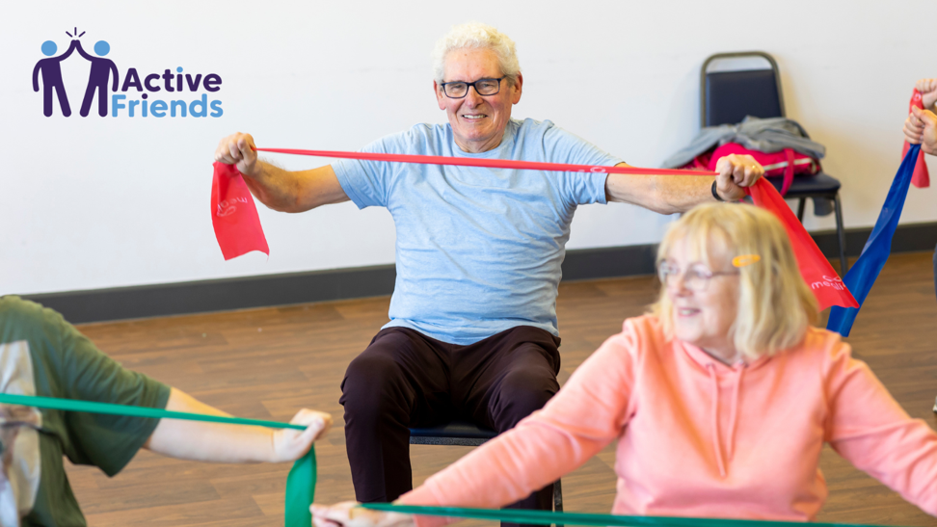

Exciting news! The Active Friends toolkit is here!🤩

This FREE toolkit by @cdsport teaches you the knowledge & skills to support others to move more, & get moving yourself!

Start making a difference in your community, visit the Active Friends toolkit: http://ow.ly/1hzC50JKhzM

_____________________________________________

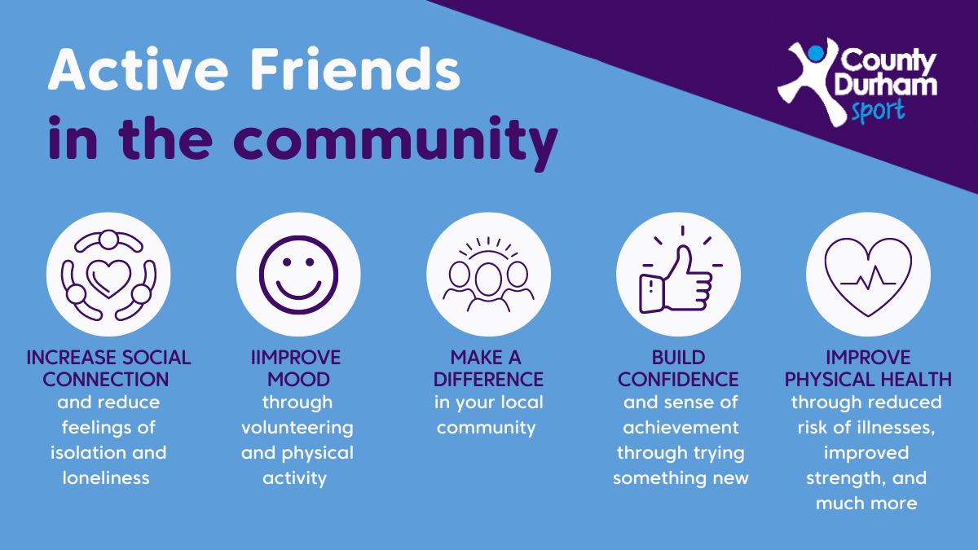

Have you heard about the Active Friends toolkit from @cdsport?

The toolkit can help you to support & inspire others to get moving. Plus, gain the benefits of moving & volunteering yourself! 🙌

Anyone can be an Active Friend! Join the community here: http://ow.ly/1hzC50JKhzM

______________________________________________

Would you like to play an active role in your community and positively change lives?

Why not become an Active Friend?

The Active Friends toolkit from @cdsport teaches you how to inspire others to get moving.

Anyone can do it! Check out the toolkit👇
http://ow.ly/1hzC50JKhzM

_______________________________________________

Twitter: Business facing posts

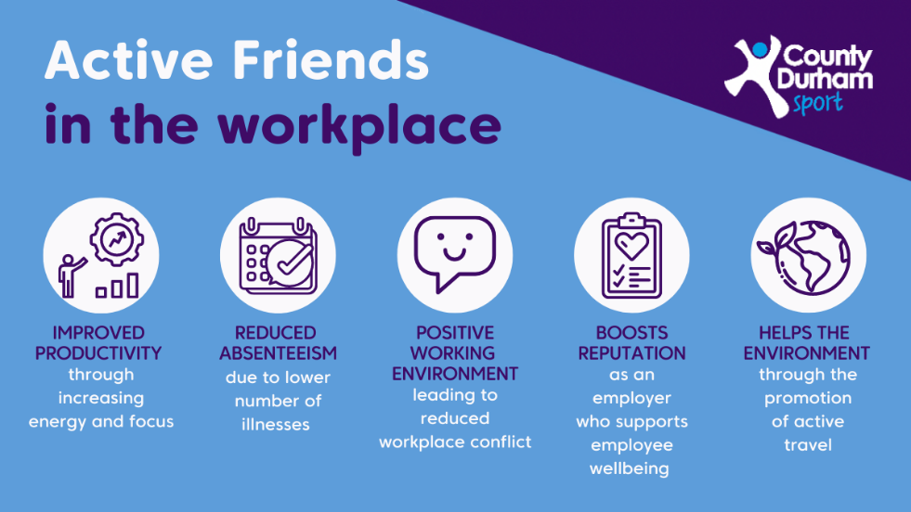

The Active Friends toolkit from @cdsport is here!

Having a community of Active Friends in the workplace, supporting & inspiring others to move more, can greatly benefit employees and employers.

Get Active Friends in your workplace, head to: http://ow.ly/1hzC50JKhzM

_______________________________________________

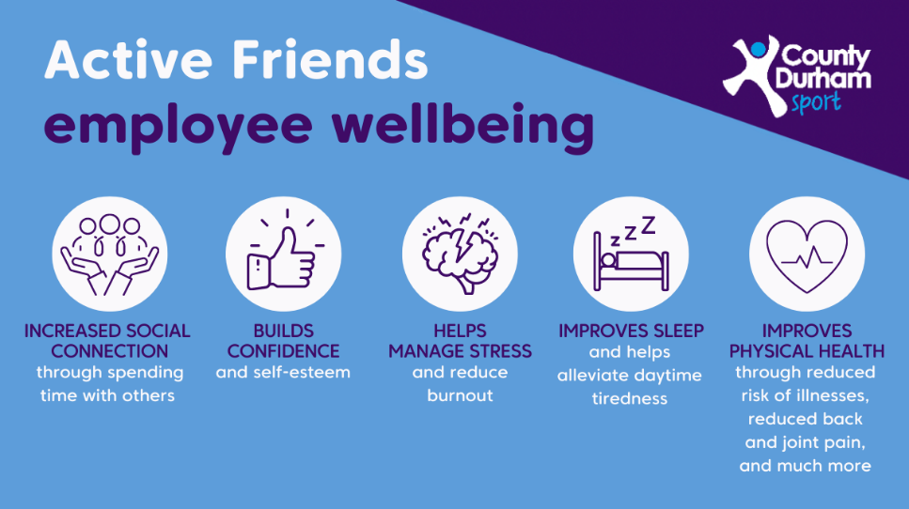

Have you heard about @cdsport's Active Friends toolkit?

It teaches you the skills to get people moving!

With colleagues in your organisation as Active Friends, you’ll be better able to support the wellbeing of your employees.

Discover more: http://ow.ly/1hzC50JKhzM

_____________________________________________

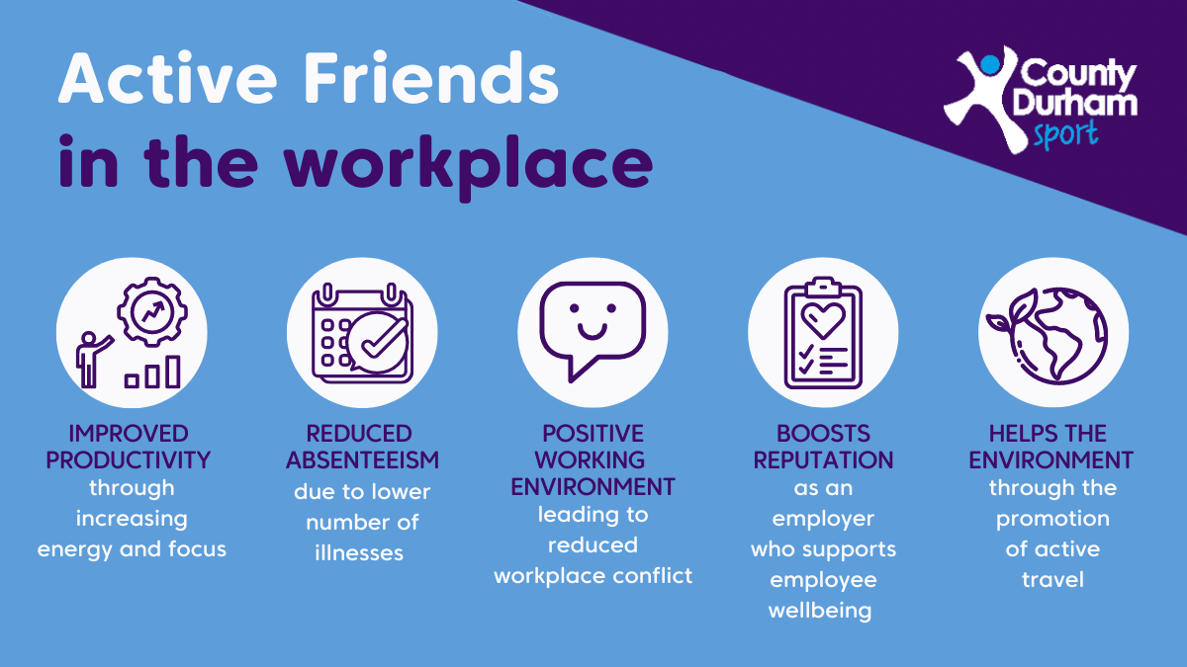

@cdsport’s Active Friends toolkit could benefit your workplace!

With Active Friends in your organisation, you can boost the wellbeing of your employees and improve your business health.

Everyone can get involved!

Get started here👇
http://ow.ly/1hzC50JKhzM
______________________________________________

LinkedIn: Business facing posts

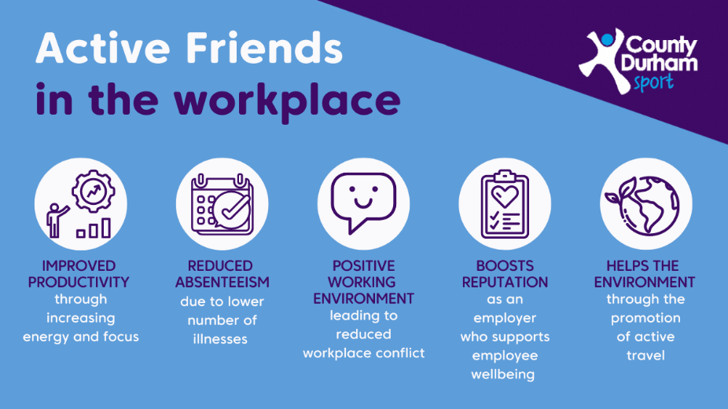

The Active Friends toolkit is here!

This FREE toolkit by County Durham Sport teaches the knowledge & skills needed to support others to move more and get moving yourself.

Active Friends can benefit your workplace (including when working from home!), as physical activity plays an important role in employee health and wellbeing. With colleagues within your organisation as Active Friends, you will be better able to support the wellbeing of your workforce, which is more vital than ever.

Expand your knowledge and learn:
- What is physical activity?
- The benefits of physical activity
- How to get people active
- Why walk?
- How to be Active Friend

A working environment that encourages employees to move more has many benefits, not only for employee health, but for organisation health.

Discover Active Friends here: https://countydurhamsport.com/active-friends/

______________________________________________

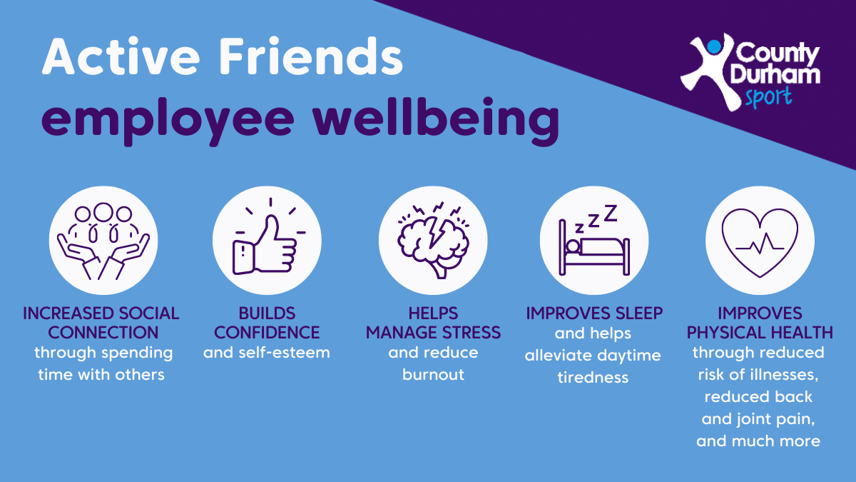

County Durham Sport’s Active Friends Toolkit could benefit your workplace!

Physical activity plays an important role in employee health and wellbeing. As an employer, you can promote physical activity in your workplace, and the Active Friends toolkit will teach you the knowledge and skills to do just that.

Would your organisation like to become Active Friends and make a positive difference in the workplace?

Visit the Active Friends toolkit here and get started: https://countydurhamsport.com/active-friends/

______________________________________________

Facebook: Community facing posts

Exciting news! The Active Friends toolkit is here! 🤩

Getting active is easier with the support of a friend. This FREE toolkit by County Durham Sport teaches you the knowledge & skills to support others to move more, and get moving yourself!

Expand your knowledge and learn:
✅ What is physical activity?
✅ The benefits of physical activity
✅ How to get people active
✅ Why walk?
✅ How to become an Active Friend

Make a difference in your local community, visit the Active Friends toolkit:
http://ow.ly/1hzC50JKhzM

__________________________________________________

Have you heard about the new Active Friends toolkit from County Durham Sport?

The free toolkit will help you to support & inspire others to get moving. Plus, gain the benefits of moving & volunteering yourself! 🙌

Learn about the many benefits of moving more and help members of your community boost their health and wellbeing.

Getting moving is easier with the support of a friend. Become an Active Friend and help change lives: http://ow.ly/1hzC50JKhzM

____________________________________________________

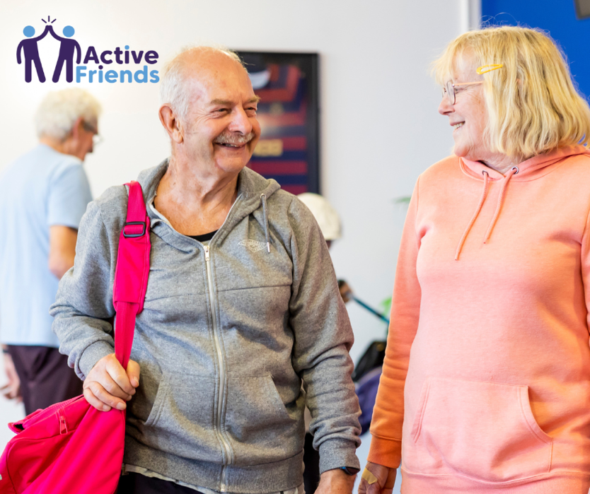

Would you like to play an active role in your community and positively change lives? 🙌

Why not become an Active Friend?

Active Friends promote the benefits of moving more, and support and inspire people on their journey to being more active.

Anyone can be an Active Friend! No qualifications are needed - you don’t even have to be active currently 😄

Start your journey here: http://ow.ly/1hzC50JKhzM

