A= 10 star jumps | 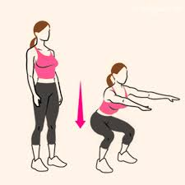  B=5 Squats | 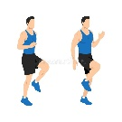  C=High knees 10 seconds | 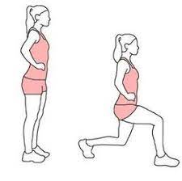  D=10 Lunges | 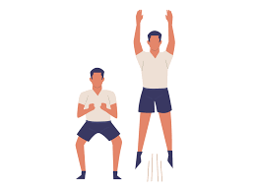  E=5 rocket Jumps
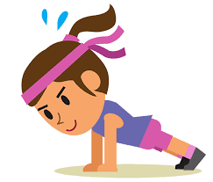  F=10 Hot Hands | 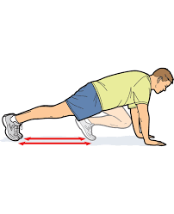  G=5 mountain climbers | 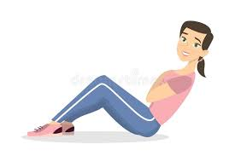  H=5 sit ups | 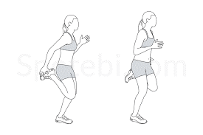  I=Heel kicks 10 seconds | 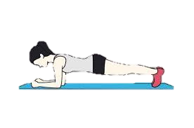  J=Plank 5 seconds
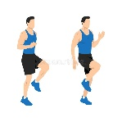  K=15 seconds High knees | 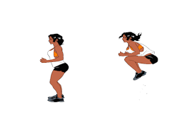  L=5 tuck jumps | M= 5 hot hands | N= 10 mountain climbers | O=10 sit ups
P= 15 Squats | Q= 15 sit ups | R=20 star Jumps | S= 10 squats | T= 10 rocket jumps
U= 5 lunges | V= 15 hot hands | W= 10 tuck jumps | X= 15 tuck jumps | Y= 10 seconds plank
Z=15 Rocket Jumps

