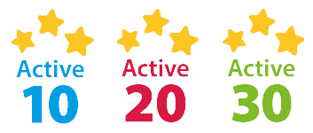

**Aim:**

**Activity Name:**

**School:**

**Name:**

**ACTIVE 30**

**RESOURCE TEMPLATE**

**2021-22**

Can you write down a warm up, cool down or personal challenge link to your game that people can try at home:

**Warm Up / Cool Down / Personal Challenge:**

How can you adapt the activity / game to play at home?

**Space -**

**Task -**

**Equipment -**

**People -**

Instructions:

How many people do you need? How to play the activity / game? What are the rules (including diagrams)?

Equipment required to play?



**Main Activity:**