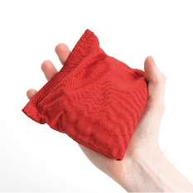**Bean Bag Skill Challenges**

**\*if you want to try these at home and you don’t have a Bean Bag you can use a Bag of Crisps (easier) or Pair of Socks rolled up (harder)\***

1. Balance Bean Bag on your head
2. Whilst bean bag is on your head bend your knees and touch your right toe with your right hand
3. Touch your left toe with your left hand
4. Touch your left toe with your right hand
5. Touch your right toe with your left hand
6. Walk to the end of the grid with the beanbag on your head
7. Fast walk to the end of the grid with the beanbag on your head
8. Run to the end of the grid with the beanbag on your head

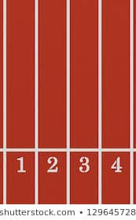

*Create your own grid for challenges 6-8

1. Lift your right knee to 90 degrees and balance the bean bag on it and see if you can count to 10 seconds
2. Repeat with left knee
3. Lift your right foot and balance the bean bag on it and see if you can count to 10 seconds
4. Repeat with left foot
5. Throw Bean Bag up in the air (past head height) and catch with both hands
6. Throw Bean Bag up in the air (past head height) clap your hands and catch with both hands
7. Throw Bean Bag up in the air (past head height) and catch with your right hand only -Extension Activity- how many can you do in a row without dropping the bean bag
8. Throw Bean Bag up in the air (past head height) and catch with your left hand only -Extension Activity- how many can you do in a row without dropping the bean bag
9. Use alternate hands to catch the bean bag – How many can you do?

**\*Now think of some of your own Bean Bag skill challenges\***

