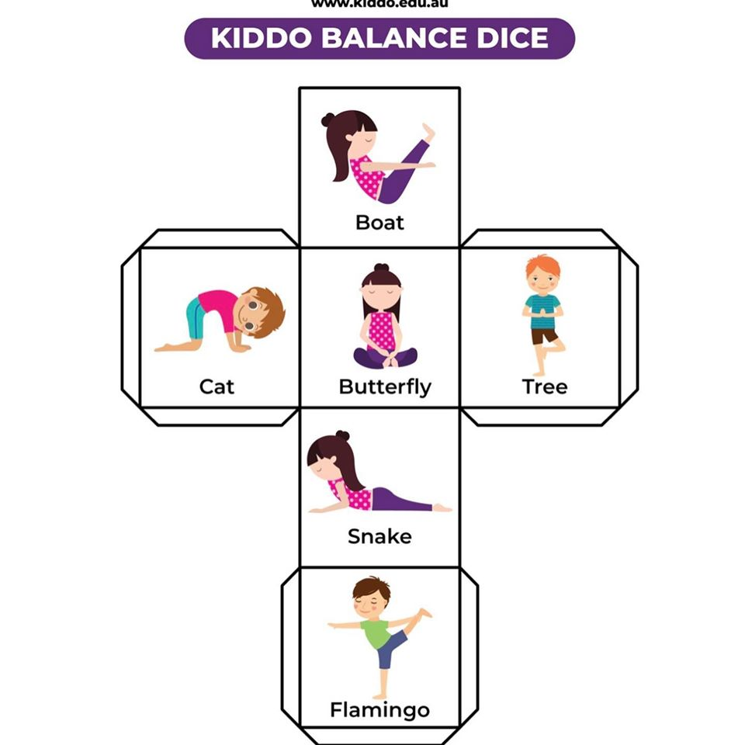

Simply print off this piece of paper, cut the outline of your ‘balance dice’ out and fold and stick the edges to create your dice.

Roll the dice and perform the balance it lands on